Injury prevention programme for 11 year old swimmers
The England Talent screening programme has now been going for 2 full years and following on from this we have analyzed the data collected. From the data we can see there has been a correction of muscle imbalances, improvement of movement ranges and posture correction in the swimmers we have assessed. The ages of the swimmers assessed are 12-15 and even from the age of 12 the swimmers show imbalances, poor posture and changes in the ranges of movement. These changes are known to predispose to injuries of the Lower back, shoulder and knee in swimmers at a later stage in their careers. Prevention is known to be better than cure so if we can prevent these changes occurring we can hopefully prevent the injuries occurring later in their swimming careers.
From the data we have collected we have devised an exercise program for 11 year olds to prevent the changes in the muscle length, range of movement and posture occurring, This exercise program should be done 3 times a week and will take approximately 30 minutes to complete. It can be done at the club land sessions or at home. The exercises are safe to do and will prepare the 11 year old swimmers to be able to progress in the sport and with their land work with fewer injuries.
One area that was poor with the swimmers was the flexibility of muscle. When swimmers were asked about how often they stretched they admitted this was very rarely. Whilst we don’t want over stretched muscles we do want the muscles to go back to their normal length after exercise. Stretching post exercise can reduce muscle to their normal length after exercise. Stretching post exercise can reduce muscle soreness and will help return the body to normal quicker than not stretching. Therefore swimmers should be encouraged to stretch for 10 minutes after every pool and land session.
In this article we are covering the core exercises for 11 year olds. This does not include the stretches that every swimmer should do after training.

Exercise program
1. Squat control
For this exercise you will need to place an exercise band around the knees. The band should be tied around the knees and the knees should be 3 inches apart when the band is relaxed.
Stand with the feet hip width apart and the hands above the head in a streamline position. Take the knees outwards until the knees are over the feet. During the exercise the knees should stay in line with the second toe at all times. Slowly squat taking the bottom towards the heels and keep the weight in the heels. Make sure the back stays straight and the head does not drop forwards
Repeat this up to 20 times
2. Balance
The ages of 4-11 are the best time to improve balance. If poor balance continues into the teenage years this may cause problems when impact work is done during land sessions. Simple exercises to improve balance can make a massive improvement on core stability.
Stand on one leg. Slowly take the arms into a streamlined position. Gradually lift the raised leg and extend it at the same time as flexing the hip. You should end up in a straight line horizontal streamline position.
Hold this for 20 seconds
Repeat on the other leg
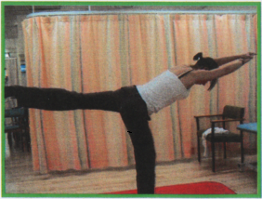

3. Cuff work
The rotator cuff are muscles which act together to help keep the humeral head in the centre of the shoulder joint. They are very important in swimmers as the shoulder is at risk of impingement and instability caused by overuse of certain muscles.
Stand with the exercise band attached to a door handle. Make sure the door is closed and will not come open whilst you are exercising.
Stand sideways to the door. Make sure you have good posture with the weight evenly between the feet, tummy tucked in and shoulders rolled backwards. Keeping the elbow into the side slowly pull the band to the side making sure your arm is close to your side and elbow stays at 90 degrees. Take the forearm as far as you can – hold for 3 seconds and slowly release.
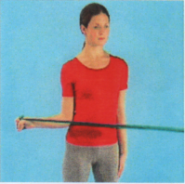
Repeat this 20 times with each arm

4. IR stretches
In swimmers the range of internal to external rotation at the shoulder is often different to in non-swimmers. The internal rotation becomes limited and poorly controlled. This means as you pull through the water you will be able to generate less power. It also means you are at risk of shoulder problems. Therefore you need to stretch the shoulder rotation.
Lie on one side with your arm out at 90 degrees to your body. Bend the elbow to 90 degrees. Use your other arm to gently push the forearm towards the bed. Hold at the end of range for 10 seconds. Repeat this 3 times with each side
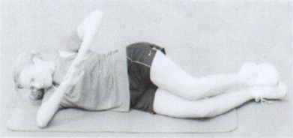

5. Shoulder blade work
Lie on your front with the arms by your sides. Gently pull the shoulder blades together as far as they will go. Then ease off a little and hold this position for 10 seconds. Repeat this 10 times. This exercise works the shoulder blade muscles and helps with posture
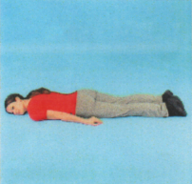

6. Gluts
These are the muscles of your buttocks. They are really important in controlling the position of the leg when you are weight bearing. They also help the core muscles to strengthen the back.
Lie on your side with your knees and hips bent. Put your hand behind your hip and make sure the hip is pushed forwards. Keep the ankles together and slowly raise the knee as far as possible. It is important you do not let the hip roll backwards.
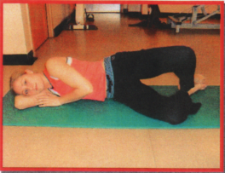
Repeat this 20 times with each side

7. Basic core exercises
This is the basic core stability exercise. It is extremely important to know how to work this muscle and how to out your back into a good posture

A good spine position is called spinal neutral.

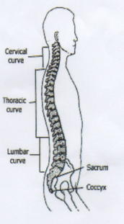

In spinal neutral all the curves of the spine are in a good alignment and the spine is at its strongest.

To find your spinal neutral position follow the steps:

a. Lie on your back with your knees bent and your feet flat on the floor. Make sure that your legs are parallel with your heels, toes, knees, and hips all in one line. Let your arms rest at your sides

b. Press your lower back into the floor by tilting the pelvis then breathe out and pull the spine away from the floor.

c. Repeat step 2 several times until you reach a position where your lower back is straight (not arched or pushed into the floor). This is your spinal neutral position. There should be a small gap between the lower back and the floor.

After you have found the spinal neutral position you need to turn on your deep core muscles. This is done as follows:

a. Find the spinal neutral position

b. Place your hands either side of your hip bones to feel the deep muscles.

c. Gently draw your belly button towards the spine whilst breathing out at the same time.

d. Hold this contraction for 10 seconds whilst breathing gently.

8 Thoracic stretches

- Lying face down with your arms above your head in line with your body
- Lift your upper trunk off the floor
- Hold 10 seconds
- Repeat 10 times

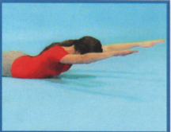

9 Core exercises – bend knee fall out

Lying on your back with the knees bent. Tighten the abdominal muscles and contract the core muscles. Put your hand on your hips to make sure they do not move off the floor. Bend one knee and slowly let it lower sideways towards the floor. Only go as far as you can without the hips moving. Slowly bring the leg back in

Repeat 20 times each leg

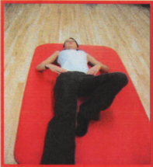

10 Bridging

This is a core exercise to work the core muscles and the gluteal muscles

Lie on your back with your knees bent and the arms above the head in streamline. Tighten the core muscles. Slowly lift the bottom off the floor until you have a straight line from your knees to your shoulders. Hold this position for 10 seconds.

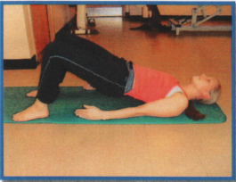

Repeat 10 times

11 Superman

This is a core stability exercise which also tests the balance.

Start on all 4’s with the knees directly under the hips and hands under the shoulders. Tighten the core muscles. Make sure that all the way through the exercise the trunk does not move. Slowly lift one arm outstretched. Keep the body stable. Then lift the opposite leg out backwards again keeping the core stable.

Repeat with the other arm and leg.

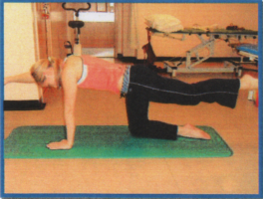

Repeat this 20 times each side

Conclusion

These exercises form the starting point for land exercises that are safe to use with young children. Once young children have developed basic core skills, posture and shoulder control they will be able to progress onto more advanced exercises and hopefully their performance will be enhanced. The aim of the exercises is to prevent the muscle imbalances that occur through regular swimming and hopefully reduce the number of injuries occurring later on in their swimming careers. Once these swimmers progress onto the England Talent camps we will be able to monitor whether there are fewer imbalances through doing regular land based exercises from the age of 11.

